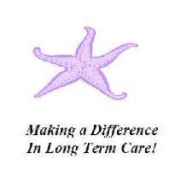
Ombudsman Program

The Ombudsman Programs is an important program that provides “resident directed” advocacy for residents of Long-Term Care facilities. The program provides information to residents and families about their rights, regulations, resources. The Ombudsman Program also provide educational trainings for staff and residents. Cumberland County has 38 licensed facilities that require a minimum of 4 quarterly visits each year as well as 2 adult day centers and 1 LIFE program that require an annual visit.

The training follows a specific path to assure you are well equipped. The training is extensive and includes several shadowing visits with Ombudsman staff, independent online training modules, and classroom trainings. The volunteer can expect more than 38 hours of training over a 4-6 month period. Following your certification, the program requires a minimum of 3-4 hours each month. You must complete a Conflict-of-Interest screening prior to entering the program.

Training
- 13 online trainings. (Each webinar is approximately 30 minutes)
- 14 shadowing visits with staff Ombudsman
- 8 classroom trainings (each training is done virtually and is about 2 hours)

